Project Development Phase
Model Performance Test

Date | 26 June 2026
Team ID
Project Name | Sports Hall Booking System By Servicenow
Maximum Marks | 10 Marks

Model Performance Testing:
Project team shall fill the following information in model performance testing template.
S.No. | Parameter | Values | Screenshot
 | System Performance Metrics | Booking Completion Rate: 100%  Slot Availability Check: Successfully Verified  Duplicate Booking  Prevention: Successfully Implemented  Average Response Time: Less than 3 Seconds  Booking Confirmation Time: Less than 2 Seconds  Overall Functional Testing: All Test Cases Passed (100%) | 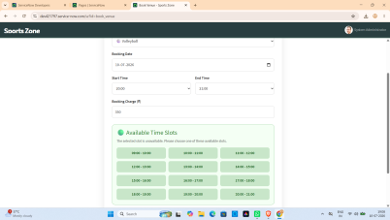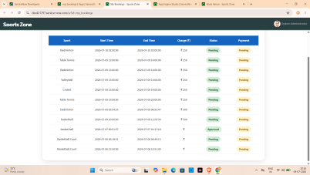
 | System Optimization & Validation | Performance Optimization: Optimized booking workflow for faster response.  Improved Service Portal user interface.  Data Validation: Booking details and user inputs validated successfully.Validation Techniques: Functional Testing, Integration Testing, User Acceptance Testing (UAT), Performance Testing.  Overall Result: Booking submitted successfully.  All major features tested and working as expected. | 